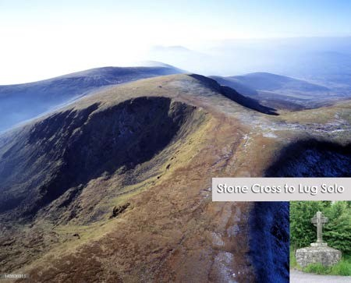

**Stone Cross to Lug Race Booklet**

**Date: Saturday, 21st Sept. 2024**

*(booklet last updated 28.07.24)*

# Table of Contents

Race Outline .................................................................................................................................. 3

Race Entry ..................................................................................................................................... 4

Race Day Itinerary ......................................................................................................................... 4

Race Location & Parking ............................................................................................................... 5

Race-Day Registration …………………............................................................................................... 6

Facilities at Start / Finish Line (Fenton’s Bar) ............................................................................... 7

Littering .........................................................................................................................................7

Withdrawal from the Race ........................................................................................................... 7

Important Contact Details ............................................................................................................ 8

Mandatory & Recommended Kit/Equipment .............................................................................. 8

Prize Giving...………………………………................................................................................................ 9

Course Overview & Maps.............................................................................................................. 9

Photos of Control Points................................................................................................................16

Please ensure that you check the event webpage (<https://www.imra.ie/events/details/id/2398/>) and IMRA forum for changes and updates closer to race day. It is advisable to download the latest copy of this race book during the week leading up to the race and monitor the IMRA forum right up to the night before the race. The Solo and Relay event page info’s are the same.

## Race Outline

The Stone Cross to Lug Solo & Relay race is a long-distance open mountain race starting near Stone Cross at Ballinascorney Upper and finishing at Fenton’s Bar in the Glen of Imaal. The race will climb over some of the highest peaks in the Dublin and Wicklow Mountain ranges including Kippure (757m), Mullaghcleevaun (849m), Tonelagee

(817m) and finally Lugnaquilla (925m) with a long fast descent down to Fenton’s Bar.

The race route is not marked. Runners **must** however hit a number of specified points along the way but route choice between these control points is free choice.

The total route is approximately **54km** in distance, with a total climb in the region of **2250m**. This will vary slightly from runner to runner depending on exact route choices taken between controls.

This is a Non-GPS race therefore GPS assistance is **NOT** allowed for this race. All runners must have experience of navigation and must be able to use a map and compass. It is highly recommended that all runners recce their routes in advance of race day.

There will be a food Drop-Bag facility & water refill at the two CPs - Sally Gap and Wicklow Gap. **Drop bags should be SMALL & clearly labelled with your name and race bib Number**. Drop bags will NOT be brought to finish.

Trackers will be provided at registration and all runners are to ensure the safe return of tracker at finish line.

All entrants must accept they have to make their own arrangements for getting to the start and from the finish. SOLO entrants should have a back-up plan in the event of missed cut-off or drop-out. We will not have volunteers/cars to transport runners to/from start/finish etc.

Runners are to be aware that phone reception at many points throughout the route can be poor to none. Please bear this in mind should you require a family member or friend to pick you up.

## Race Entry

The race is open to all IMRA members aged 18 or over on the date of entry.

Entries will be capped at 60 participants.

Annual IMRA membership and race entry can be purchased through the myIMRA section of the www.imra.ie website. Runners must be current members of IMRA and hold a valid 2024 ‘race number’ on the day of the event. If this is your first race of the year, then your ‘race number’ will be available at the check-in desk on the morning of the race.

Race entries will open on **Saturday, 24th August** **at 9am** and close at **6pm on** **Saturday, 14th September** or when 60 entries have been received.

There will be **No** entry on the day of race, online entry only for this race.

## Race Day Itinerary – 21st of September 2024

### Time Detail

07:00 Registration Opens at Start Line Location

07:50 Registration Closes

07:55 Race Briefing at the Start Line

08:00 Race start – All runners (No early starts)

17:30 Prize Giving at Fenton’s Bar

There will be no early start facility for this race and all runners will start at the 8am gun-time.

## Race Location & Parking

### Start Line

The start line will be situated at a forest entrance approximately 2km south of Stone Cross (also known as Famine Cross) just off the Ballinascorney Road. Grid Reference for start line is O-075,205.

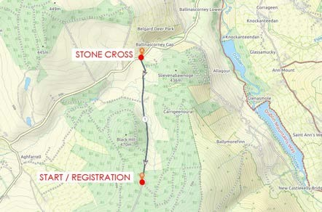

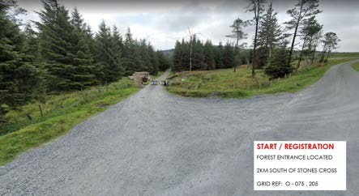

### Parking

There is very limited on street parking at the start line, and due to the start and finish locations being so far apart that we ask all runners to arrange to be dropped to the start line if possible.

Cars parked at the start line for the duration of the day are done so at the owner’s risk.

There are no buses or public transport to take runners from the Finish Line back to the Start Line to collect their cars, so please make alternative arrangements.

It is not unusual for runners to do a car drop to Fenton’s Bar either early on the race morning or the night before and arrange a lift to the start line. Approximate driving time from Fenton’s Bar to Start Line is roughly 40-45mins (44km).

## Race-Day Registration

Race day registration will be located at the start line. Runners should bring their 2024 IMRA race number to registration. Those collecting their 2024 IMRA number for the first time will do so at registration.

We ask all entrants to please log in to their IMRA online account and ensure that the correct mobile phone number is listed on their account. This mobile number must match the mobile phone runners will be carrying on the day of the race.

## Solo & Relay Mandatory and Recommended Kit/Equipment

Kit checks will form part of sign-in at registration on race morning; all runners **must** carry the mandatory kit as listed in the Mandatory & Recommended Kit/Equipment section below for the complete duration of the race. **Relay leg runners can sign-in and have their kit checks done at their start point – Sally Gap or Wicklow Gap.**

Mandatory Kit List:

* IMRA Race Number
* Map(s) of complete Race Route
* Compass
* Rain Proof Jacket
* Hat or Buff
* Whistle
* Fully charged Mobile phone with IMRA Emergency number saved.
* Foil Blanket
* A supply of Emergency Food to sustain a minimum of 2hrs of activity.
* Water (500ml min.)
* Tracker - **To be fitted on your backpack at registration on race morning.**

Recommended Kit:

* Rain proof pants and long sleeve base layer
* Gloves
* Midge Repellent
* Basic first aid kit capable of cleaning and covering a minor wound
* Full leg cover; running leggings, ¾ tights & Long socks or similar.

The mandatory kit must be carried for the entire duration of the race by each runner. Failure to do so will result in runner being disqualified.

If you have any questions regarding the kit please contact the race director or post a message on the IMRA forum section under the event details page.

Runners are advised to check the weather in advance and to select their kit or additional kit based on their perceived requirements on the day. The list here is provided as a minimum. This is a tough open mountain race with rough terrain and high ground where weather conditions can change in an instance. Please consider your own experiences and select your clothing/equipment accordingly

Facilities at Start Sheehan Forest Barrier / Finish Line (Fenton’s Bar)

Nervous runners.

Fenton’s Bar-Hot Food

## Littering

IMRA has a strong leave no trace policy. Please contain your rubbish for disposal at each checkpoint or at the finish line.

## Withdrawal from the Race

All runners who decide to pull out of the race along the route **must** inform the next Race Marshall of their decision so race officials can account for their absence.

If a Race Marshall is not close by then please contact the Race Director via the IMRA Emergency contact number which must be stored in your mobile. The IMRA emergency contact number is **0872617599**. This number will be redirected to the mobile phone of the Race Director on the day.

Please be aware that it is vital that we know if you decide to pull out of the race. It saves volunteers unnecessarily standing around for hours awaiting your arrival or worse still having to go look for you!

Race Marshalls will be located at both Sally Gap Crossroads and Wicklow Gap/ Turlough Hill carpark. If you feel you need to abandon ship, then please try do so at one of these locations.

## Important Contact Details

Race Director – 0872617599 (calls only, **no texting**)

IMRA Emergency Number (calls only, **no texting**): 0872617599 – save the number to your phone now to have it handy.

IMRA Website: www.imra.ie

## Overall Prizes

The ranking of finishers will be based on race time.

Prizes will be awarded to the following categories only.

1st, 2nd 3rd – Male and Female

## Course Overview

The Stone Cross to Lug course can be broken down into 3 Legs. Cut-offs times will be in operation at the end of Leg 1 & 2.

Runners must run and touch either the trig point, cairn, summit stones or designated point of the controls listed under each Leg. Short cutting or failure to run all the way to the designated control point is frowned upon…so make sure you hit that target!

**Leg 1** (15km) – Start to Sally Gap Crossroads

* Start Line (436m)
* Seahan (648m)
* Corrig (618m)
* Seefingan (724m)
* Kippure (757m)
* Sally Gap Crossroads (Marshal Checkpoint: cut-off time 11:00am)

**Leg 2** (17km) – Sally Gap Crossroads to Turlough Hill Carpark

* Sally Gap Crossroads (495m)
* Carrigvore (682m)
* Gravale (718m)
* Duff Hill (720m)
* Mullaghcleevaun East Top (795m)
* Mullaghcleevaun (849m)
* Stoney Top (714m)
* Tonelagee (817m)
* Turlough Hill Carpark (Marshal Checkpoint: cut-off time 2:30pm)

**Leg 3** (22km) – Turlough Hill Carpark to Finish

* Turlough Hill Carpark (476m)
* Turlough Hill Communications Hut (681m) (Grid ref: T-063,983)
* Conavalla (734m)
* Table Track Junction (690m) (No requirement to go to cairn at Table Mountain) (Grid ref: T-021,967)
* Camenabologue (758m)
* Cannow (796m)
* Lugnaquilla (925m)
* Camarahill (480m)
* Finish Line (200m) Fenton’s Bar

### **LEG 1:** Start to Sally Gap Crossroads (CUT-OFF 11:00am)

The first leg of the race starts with a short quick climb up to the obelisk of Seahan (648m). There are several different routes up to Seahan and runners quickly disperse in numerous directions after a short run on the forest track.

Runners converge at Seahan from all directions, and it is not clear which is the faster route. All depends on what type of ground you prefer so get out and do those recces!

From Seahan it is a short hop over to Corrig. Ground here is boggy and even in dry periods can still be very wet so make sure those shoes are tied on tight!

Leaving Corrig it is a fast downhill in the direction of Seefingan. Again, very boggy on the saddle so pick your route quickly and avoid going knee deep. It is still early in the morning at this stage so chances are the morning mist may not have burnt off just yet and visibility will be low. Trust your compass bearing, and you should hit the track to start the small climb up to Seefingan.

At Seefingan there is no requirement to run over the Passage Tomb. The trig point is closer and sitting in a section of sunken bog just off the right of the track as you reach the plateau. This is where you turn left (southwest direction) and make your way over to Kippure.

The section from Seefingan to Kippure can be a tricky one at the best of times and if visibility is low then you need to have your bearings down and stick to them. There is a number of wide-open bogs which can push you off the flat either left or right away from the correct line to Kippure and result in extra climbing to get back on course. A good recce of this section is advised and can gain you valuable time on other runners around you. The trig point at Kippure is located on the north side of the fencing around the aerial as you approach it.

Leaving Kippure you are then faced with a few route choices. Do you play it safe and take the service road all the way down to the Military Road and onto Sally Gap Crossroads or do you fancy going directly off the side of Kippure and cut the corner? Be aware, even the brave sometimes avoid cutting the corner and opt for the service road. It is a fast decent on rough ground which is not to everyone’s liking! The decision is usually made there and then and not beforehand, and it is usually weather and visibility that dictates choice! If you have not recced cutting straight across then do not be foolish and take the service road. I have seen many a person lost for months down there! 😊

Check in with the Marshal at Sally Gap Crossroads and you have completed Leg 1 of this awesome race…. the warm-up Leg!

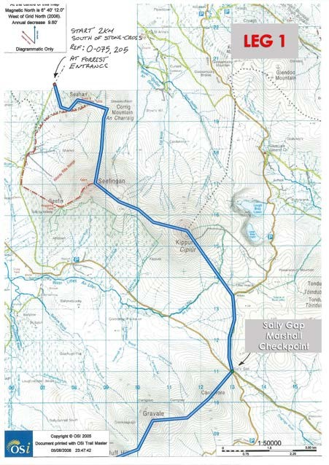

### **LEG 2:** Sally Gap Crossroads to Turlough Hill Carpark (CUT-OFF 2:30pm)

Leaving Sally Gap you start climbing up to Carrigvore. There are some overgrown trails which will take you all the way to the large granite summit stones of Carrigvore but finding the entrance from the roadside onto one of them seems to be everyone’s downfall. Make life easier for yourself and recce it!

The next couple of summits Gravale, Duff Hill, East Top and Mullaghcleevaun are real Wicklow Round territory. Although there are hit-n-miss trails linking them up the ground is very boggy, with knee height gorse and is extremely tough going if you are not on some sort of track! These all need to be recced and numerous bearings taken. A direct bearing from summit to summit will do you no favours. The transition from summit to summit is not excessive in terms of elevation lose and gain and would be considered rolling hills, but even still, if bad weather is upon you and you are not on a reasonable trail then the climbs can feel much tougher and never ending! I would put this leg down as the one that most people struggle with, make silly mistakes on and lose lots of time. Tie this section down and you will jump up a few places! ;)

From East Top it is another short hop up to the trig point of Mullaghcleevaun. Hit the trig point at Mullaghcleevaun and turn and head south in the direction of Barnacullian Ridge. Whatever you do, do not keep running straight past the trig point otherwise you will find yourself dropping quickly down onto Billy Byrne’s Gap giving yourself a very unnecessary steep climb back up!

Barnacullian Ridge is a wide-open flattish bog, almost like running on the moon. On a clear day you’ll see most of the peaks left on your race route in the distance, but on a bad day with low visibility make sure you have a bearing otherwise you’ll be drifting left and right causing additional mileage! Do not be put off by others running in different directions, stick to your plan and bearing. Be aware, this boggy section can be extremely wet, even on the driest of days, so skirting the edge could be the faster option!

Once you cross Barnacullian Ridge you are now heading for Stoney Top. The saddle section before the climb to Stoney Top can be tricky as there is plenty of runs that go in all directions, so finding the optimal route to pick up the trail leading up to Stoney Top is worth investigating. Once you hit the trail climbing to Stoney Top it is simply a case of putting the head down and keeping the feet moving. Follow the trail up over Stoney Top and continue climbing up to Tonelagee Summit. From Tonelagee you have a very long fast descent dropping you almost 400m down to the car park at Wicklow Gap where you will hit your next Marshall checkpoint. With some luck you will have paced yourself to this point and still have energy in the tank as the race only starts from this point onwards! 😊

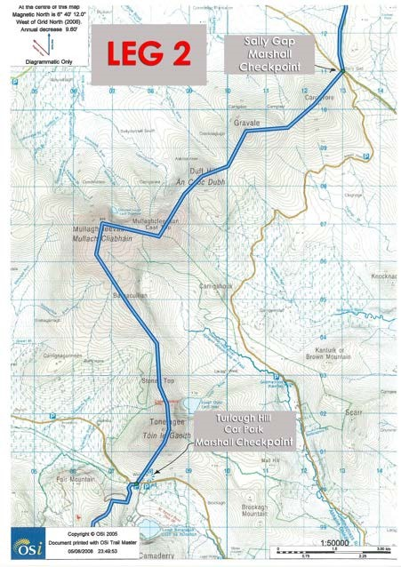

### **LEG 3:** Turlough Hill Carpark to Finish Line

A quick in and out of Turlough Hill Car Park is what you want. Do not get comfortable! Refill your bottles and keep going.

From the carpark you are climbing all the way up to the small Telecommunications Hut located about 90m South of the old Quarry. This hut is a control point and you **must** run to it. A service road from the carpark leads you all the way up to the top by the upper reservoir which then has a small trail leading up to the hut. The road has several switch backs at the beginning so possible short cuts worth investigating!

From the Hut you then decide how to get to Conavalla summit. Do you stay high and opt for the longer runnable terrain to Lough Firib, do you contour around looking to pick up some goat/deer trails or do you beeline straight from the hut dropping down and crossing the Glenealo River lower in the valley. Different strokes for different folks, so worth checking out which suits you best.

Conavalla summit is a large flat top with a few large peat haggs. There are two piles of stones located here about 50m apart. The larger pile of stones further to the south are the ones you want to hit.

From Conavalla your next control point is Table Track Junction. This is a junction located on Table Track at Black Banks Pass, between Table Mountain and Camenabologue. There is no requirement to run to the summit of Table Mountain. There is no trig point or cairn located at Table Track Junction, simply run through the junction on your way to Camenabologue.

Leaving Camenabologue summit it can sometimes take a second to pick up the trail for the descent down, but it is there…2 trails in fact! Both easier to see once you move away from the summit stones in the right direction. You will now be running along the edge of the Glen of Imaal Artillery Firing Range, so do not veer too east as this ground is out of bounds. You will see warning signs every so often and these signs should remain on your right-hand side. If on your left…you have dropped too low.

Camenabologue to Cannow is a lovely runnable trail and with a bit of luck can yield some spectacular views on a clear day.

Almost done with the climbing now, just the last slog up the grassy ridge to Percy’s Table marking the summit of Lugnaquilla, the highest point of the route. Hit the summit of Lug, turn and head due east across the flat plateau to pick up the rolling fast downhill trail to Camarahill. Be careful as you descend off the flat plateau through the step rocky section that you do not find yourself heading on the trail for Slievemaan! That is all your body needs at this stage of the race…extra km’s and unnecessary climbing!!! 😊

Continue on the trail off Camarahill down to the dreaded hard road which seems to go on forever and ever. No time to slow up, keep throwing your eye over your shoulder as there is always someone hunting you down at this late stage…hold your place! Hit the road junction, turn right and behold Fenton’s Bar…the FINISH!

You have just completed one of the best races on the IMRA calendar! 😉

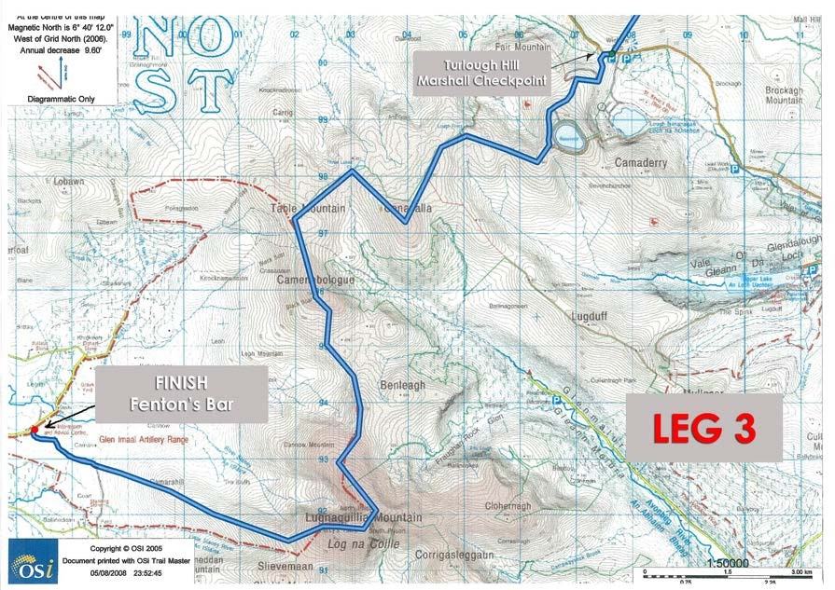

## Photos of Control Points

Below is a photo of each mandatary control point on the race route.

**LEG 1**

**CP 1 – Seehan (648)**

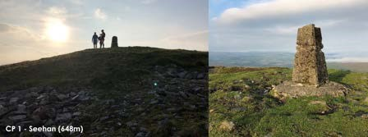

**CP 2 – Corrig (618m)**

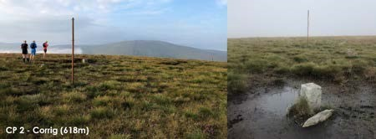

**CP 3 – Seefingan (724m)**

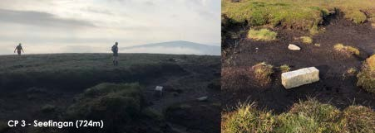

**CP 4 – Kippure (757m)**

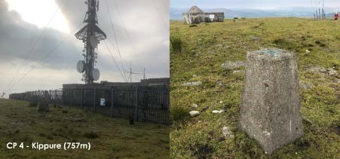

**CP 5 – Sally Gap Crossroads (Marshal Checkpoint)**

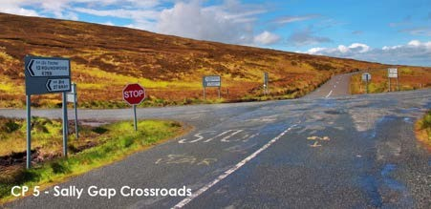

**LEG 2**

**CP 6 – Carrigvore (682m)**

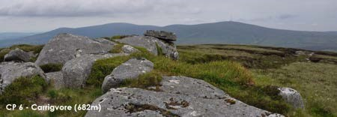

**CP 7 – Gravale (718m)**

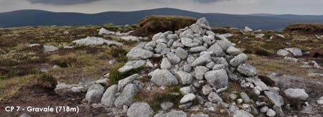

**CP 8 – Duff Hill (720m)**

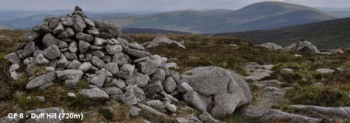

**CP 9 – Mullaghcleevaun East Top (795m)**

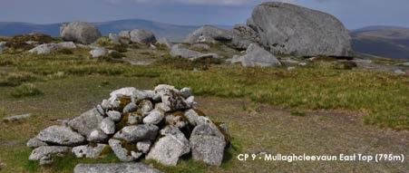

**CP 10 – Mullaghcleevaun (849m)**

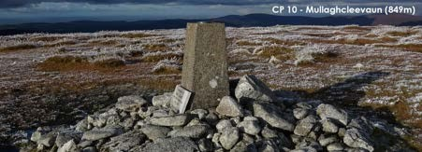

**CP 11 – Stoney Top (714m)**

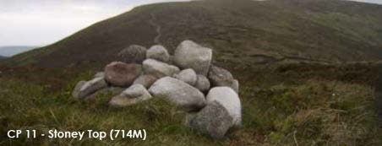

**CP 12 Tonelagee (817m)**

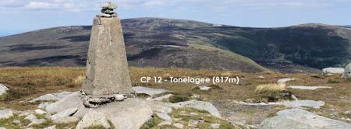

**CP 13 – Turlough Hill Carpark (Marshal Checkpoint)**

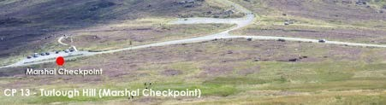

**LEG 3**

**CP 14 – Communications Hut (681m) (Grid Ref: T-063,983)**

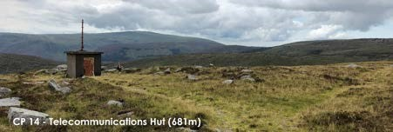

**CP 15 Conavalla (734m)**

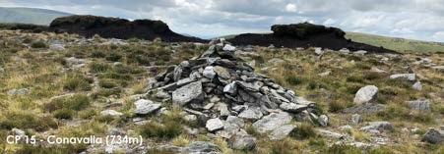

**CP 16 – Table Track Junction (690m)** (No requirement to go to Cairn on Table Mountain.

The junction is marked with a warning sign at the base of the climb up to Camenabologue.)

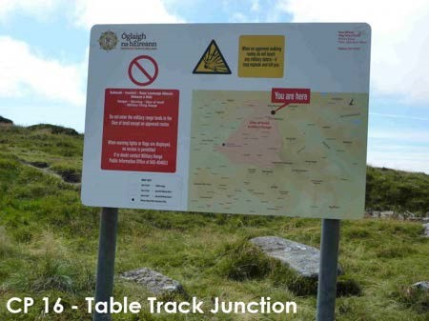

**CP 17 Camenabologue (758m)**

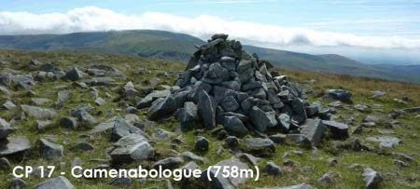

**CP 18 – Cannow (796m)**

**No distinctive summit marker. Simply stay on trail leading to Lugnaquilla, no need to deviate.**

**CP 19 – Lugnaquilla (925m)**

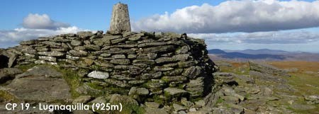

**CP 20 Camarahill (480m)**

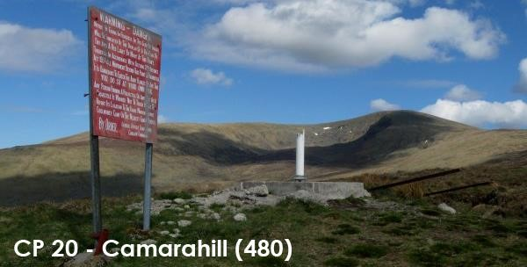

**FINISH LINE – Fenton’s Bar**

